**POST-MORTEM 1 – BROWSER GAME (ULTIMATE BENDER)**

<A NOTE TO FUTURE SELF>

27 Nov 2020, Friday || Week 3 of sei-26

**Approach and Process**

1. What in my process and approach to this project would I **do differently** next time?
   * Draw out each HTML layout on pen and paper nicely (instead of sketching and redrawing every time I need to refer to it) 🡪 try out Wire Framing tools, suggested by Nausheen.
   * Other than planning and prioritising, is to also have a timeline on what must be done at the end of the day
2. What in my process and approach to this project **went well that I would repeat** next time?
   * **PLAN 🡪 PRIORITISE 🡪 EXECUTE ONE AT A TIME**
     + Envision the final product/ outcome
       - brainstorm, draw it out, write down the user flow/journey etc
     + Break it down to the elements
       - At this point, could think about some idea of how to go about it, but don’t harp on it if you can’t figure out
     + Identify which is essential, which is good to have 🡪 prioritise the To-Do List
       - Important! So that you don’t feel overwhelmed and at a loss of where to start. Go down the list.
       - New ideas might come along the way, add them to the list and prioritise them
     + Keep calm and work on it one step-at-a-time
       - It is no use worrying. Journey of a thousand mile is starts from the first step and every step bring us closer to our goal.

--

**Code and Code Design**

1. What in my code and program design in the project would I do differently next time?
   * Use proper naming conventions. For example, HTML uses “-“ instead of camelCase as in JavaScript
   * Also a partial achievement for me was to apply the **ELM architecture**. Tried to stick to it at the beginning but kinda forgo it later in the game development as wanted to get things done within the limited time. WILL TRY FOR FUTURE LAB AND NEXT PROJECT
   * To **start thinking of more effective codes before starting hardcoding every single scenario**
     + Well, can still “hardcode” every situation, but maybe only 3-4 scenarios to help you think what is the better way to do it (put it into a function, array, object, loops etcs)
2. What in my **code and program design** in the project went well? Is there anything I **would do the same next time**?
   * One thing im proud of is to apply the architecture which Simon share in class. (ELM architecture):
     + State object. const game = {}

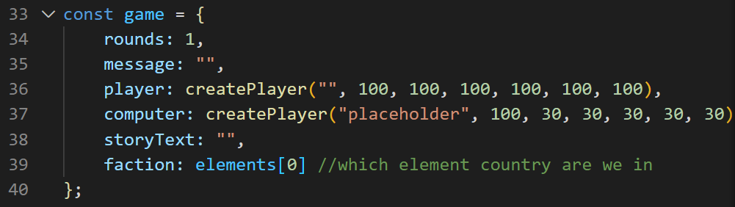

* + - Handlers

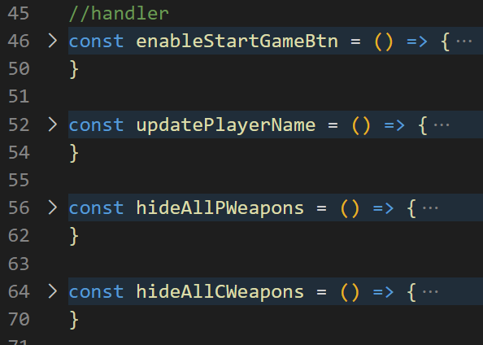

* + - Setup (e.g click events)

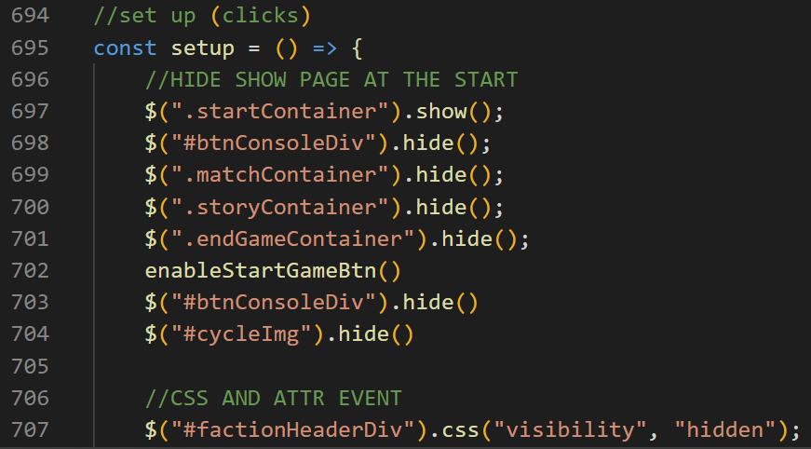

* + - Render (draw on screen)

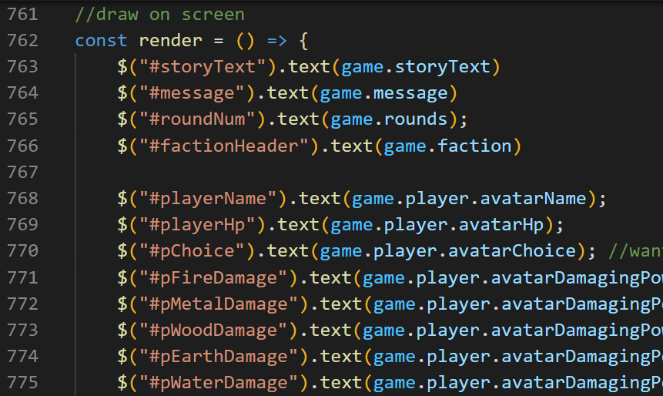

* + Simon hinted me ways to make my code more efficient instead of having to code every situation out. And instead of having to do loops key-value pairs. What we can do is an object in an object, where inputs are both keys and the value is their relationship.

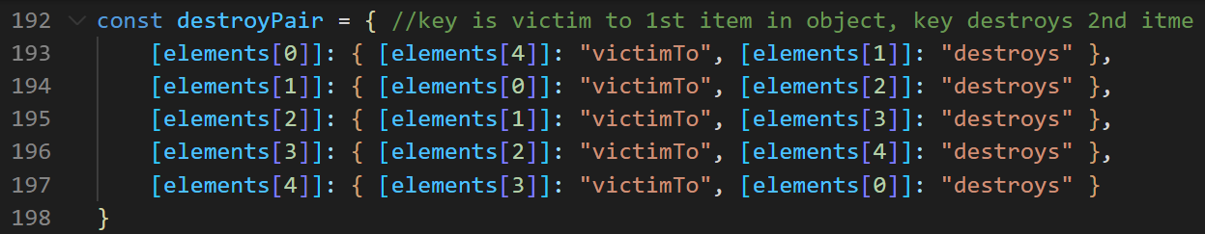

* + Another thing I learn was that a function can also be used to return a Boolean value (see line 224 and how it connects to gameLogic function on line 258

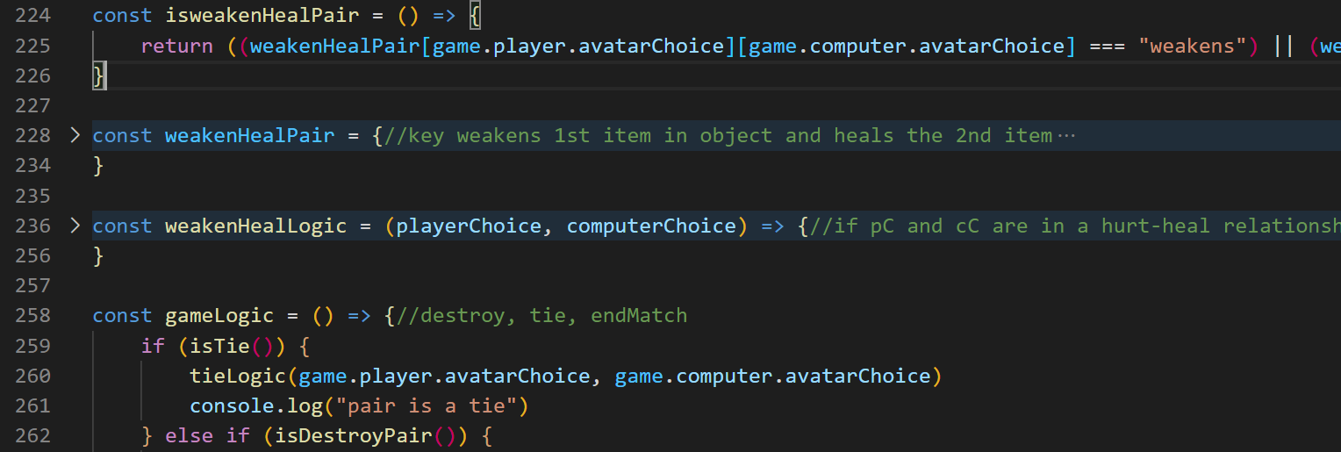

* + Another cool trick was to have a createPlayer function, essentially when you realize you are creating things with same parameters but different function, you could do this.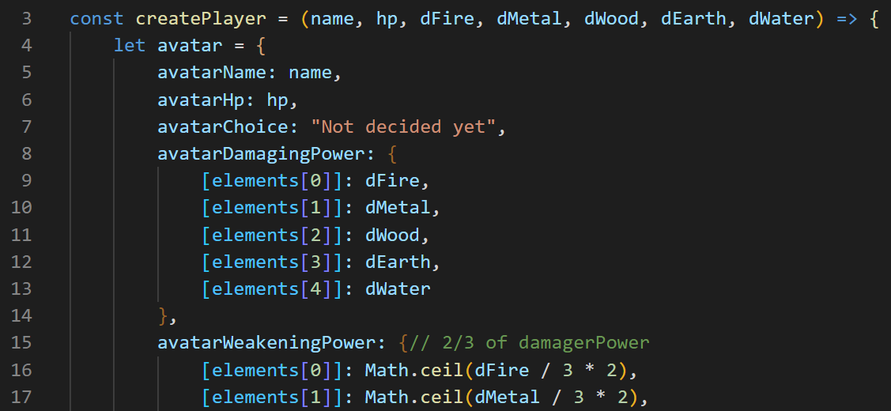

For each, please include code examples.

1. Code snippet up to 20 lines.
2. Code design documents or architecture drawings / diagrams.

**SEI Post Mortem**

1. What habits did I use during this unit that helped me?
   * Completing the homework before I sleep, not procrastinating it to the next morning, cause each day has its own workload to carry.
2. What habits did I have during this unit that I can improve on?
   * Revise what I learn at the end of the day 🡪 can do so by reading up the notes and gitBook also look through the lab exercise
   * Discipline to complete the day’s lab if didn’t manage to complete on that day itself or over the weekend
   * Maybe do up a logbook to write down what new function/tips that we covered for the day, short brief and organized one so I can refer to what we have learnt and try to apply most of it in the project.
3. How is the overall level of the course during this unit? (instruction, course materials, etc.)
   * So far 4 out of 5? It is intensive and time consuming. But overall, I’m enjoying the course, learning new things, studying all over again and its fun and satisfying to be able to create and build practical things myself.